Module Name: Login Page - Functional & UI Test Case
Test Case ID: TC_LOGIN_001
Webpage URL: https://opensource-demo.orangehrmlive.com/web/index.php/auth/login

Scenario ID: 1A
Scenario: Login with valid credentials
Test Steps:
- Open the OrangeHRM Login page
- Enter a valid username
- Enter a valid password
- Click on Login
Screenshots :
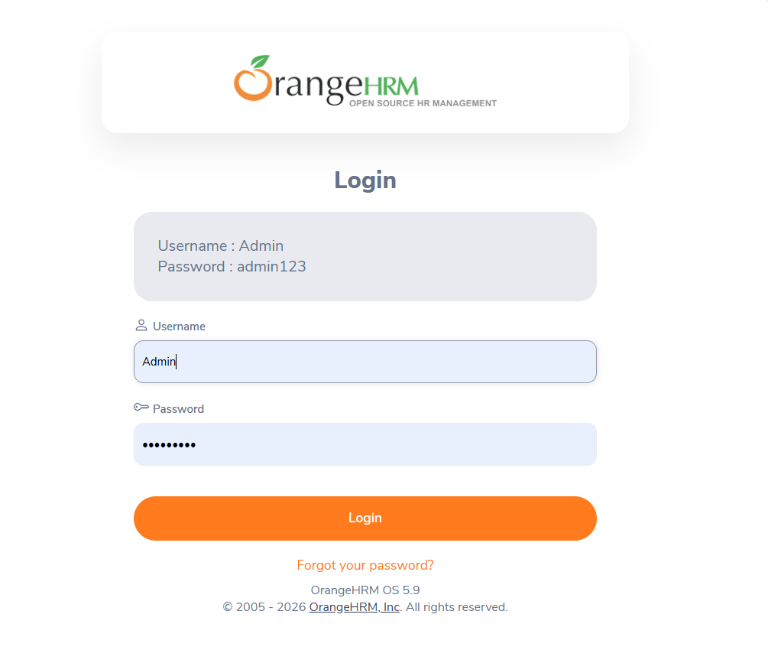

Scenario ID: 2A
Scenario: Dashboard Content Investigation
Test Steps:
- Open the OrangeHRM Login page
- Login with valid credentials
- Investigate the Dashboard UI
Screenshots :
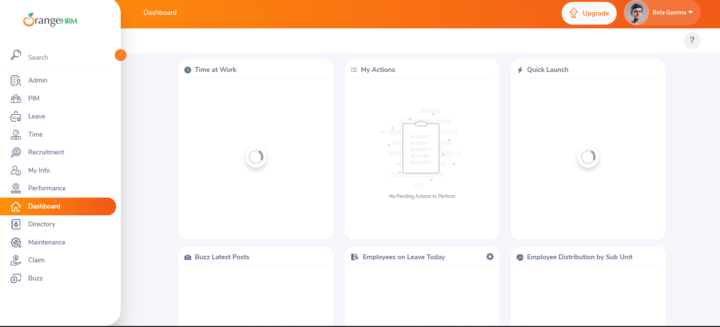

Scenario ID: 2B
Scenario: Dashboard Content Investigation
Test Steps:
- Open Dashboard
- Explore navigation
- Go to My Info
Screenshots :
